# Task - 04

**Date –** 16th July 2024

**Members of team:** Nichenametla Yadhu Vamsi, Rashmi Singh, Chandan Kumar, Vishesh Chhaperwal, Kush Thakur, Ranga Sudharani, Khushi Prajapati

## IC value chain:

The IC (Integrated Circuit) value chain in the semiconductor field refers to the entire process involved in the creation, manufacturing, and distribution of integrated circuits, also known as microchips or chips. This value chain encompasses various stages and participants, each contributing to the development and deployment of integrated circuits that power modern electronics.

Distribution

Assembly, Testing & Packaging

Manufacturing

Design

Research & Development

The IC value chain involves collaboration between semiconductor companies, design houses, foundries, equipment suppliers, distributors, and end-users. It is a complex ecosystem that drives innovation and enables the development of advanced electronics that power industries ranging from consumer electronics to automotive, aerospace, and telecommunications.

India's participation in the IC (Integrated Circuit) value chain has been steadily growing, encompassing various aspects of design, manufacturing, and research.

## Research & Development:

* American multinational semiconductor company **AMD** inaugurated its largest global design center, the Technostar research and development campus, on November 28, in Bengaluru, as part of a US$400 million investment over the next five years in India. The investment had previously been announced at the Semicon India 2023. Spanning 500,000 square feet, the Technostar campus will house around 3,000 engineers and focus on the development of CPUs, GPUs, adaptive SoCs, and FPGAs for personal computers and data centers. The facility features **a state-of-the-art research and development lab**, a visitor demo center, and collaborative huddle spaces. Jaya Jagadish, India Country Head for AMD said in a company press release, “The India Design Centre started with a handful of employees in 2004. Today, 25% of AMD’s global workforce is located in India and they support the development of AMD leadership products for data center, gaming, PC and embedded customers.

## Desing:

Companies:

* **Sankalp Semiconductor:** Specializes in analog and mixed-signal semiconductor services, including RTL design, verification, physical design, and analog layout.
* **Moschip Semiconductor Technology:** Provides design services and solutions for semiconductor and systems companies, focusing on networking, connectivity, and IoT applications.
* **eInfochips (an Arrow Electronics company):** Offers ASIC and FPGA design services, embedded systems development, and semiconductor IP solutions across various industries.
* **Tessolve Semiconductor:** Provides semiconductor engineering services including PCB design, IC testing, validation, and product engineering services.
* **Mistral Solutions:** Specializes in providing design and product realization services for embedded systems, digital signal processing (DSP), and IoT applications.
* **HCL Technologies -** Engineering and R&D Services: Offers semiconductor design and verification services, system-level design, and verification for ASICs and FPGAs.
* **Vayavya Labs (a Synopsis company):** Specializes in electronic design automation (EDA) tools and IP development for embedded systems and semiconductor companies.
* **SmartPlay Technologies (a Aricent company):** Provides digital, analog, and mixed-signal design services, ASIC design, FPGA prototyping, and verification services.
* **Cyient Semiconductor:** Offers semiconductor design services, including analog and mixed-signal design, digital design, and FPGA/ASIC verification.
* **Invecas:** Provides design services for ASICs and FPGAs, including system-on-chip (SoC) design, verification, and physical design services.

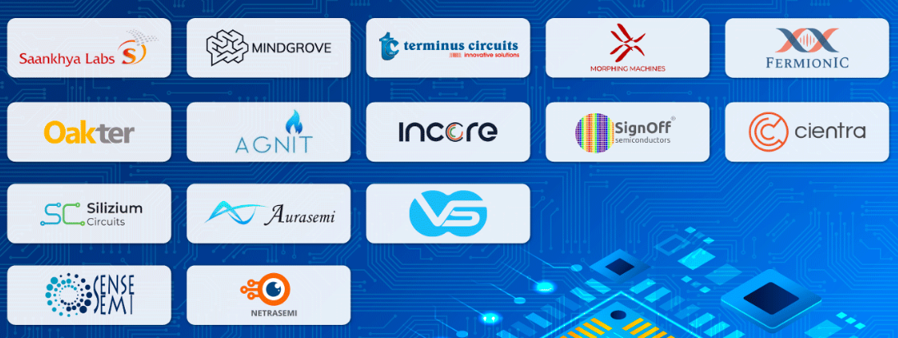

## Manufacturing:

Companies: Semiconductor Laboratory, Society for Integrated Circuit Technology and Applied Research (SITAR), ASM Technologies

* **Tata Electronics Private Limited (TEPL)** will collaborate with Powerchip Semiconductor Manufacturing Corp (PSMC), Taiwan, to establish a semiconductor fab in Dholera, Gujarat, with an investment of INR 9100 billion (US$109.71 billion). The fab’s capacity will be 50,000 wafer starts per month (wfsm), covering segments such as high-performance compute chips with 28 nm technology.
* **CG Power**, in partnership with **Renesas Electronics Corporation**, Japan, and Stars Microelectronics, Thailand, will establish a semiconductor unit in Sanand, Gujarat, with an investment of INR 760 million (US$91.63 million). The CG power semiconductor unit will manufacture chips for consumer, industrial, automotive, and power applications, with a capacity of 15 million per day.

## Assembly, Testing & Packaging:

**Semiconductor ATMP (Assembly, Test, Marking and Packaging) unit** –

* At Morigaon, Assam: **Tata Semiconductor Assembly and Test Pvt Ltd (TSAT)** will set up a semiconductor unit in Morigaon, Assam, with an investment of INR 2700 million (US$325.99 million). TSAT is developing indigenous advanced semiconductor packaging technologies, including flip chip and ISIP (integrated system in package) technologies. The unit’s capacity will be 48 million per day, catering to segments such as automotive, electric vehicles, consumer electronics, telecom, mobile phones, etc.
* At Sanand, Gujarat: **CG Power**, in partnership with Renesas Electronics Corporation, Japan, and Stars Microelectronics, Thailand, will establish a semiconductor unit in Sanand, Gujarat, with an investment of INR 760 million (US$91.63 million). Renesas, a semiconductor company specializing in chips, operates 12 semiconductor facilities and is a key player in microcontrollers, analog, power, and System on Chip (SoC) products. The CG power semiconductor unit will manufacture chips for consumer, industrial, automotive, and power applications, with a capacity of 15 million per day.
* **MICRON** **(OSAT)** -Prominent American chip company **Micron** has committed to invest up to US$825 million to build a facility in India for the assembly and testing of semiconductor chips. Making use of the government’s “Modified Assembly, Testing, Marking, and Packaging (ATMP) scheme.”

**SCL MOHALI:** SCL has an 8" CMOS and 6" MEMS wafer fabrication line with a 180 nm technology node, specialized integrated semiconductor facilities, and is equipped with tools and technologies to carry out the complex process of semiconductor fabrication. It is working on specific projects work with government of India and its body.

## b) LTSCT Collaboration:

15 July 2024 - L&T Semiconductor Technologies Partners with CP Plus to develop Semiconductor Chips for CCTV Camera Solutions

* CP PLUS and L&T Semiconductor Technologies (LTSCT) have collaborated.
* The collaboration is guided by the Ministry of Electronics & Information Technology (MeitY), Government of India.
* The main purpose is to develop indigenous Indian IP SoCs (Systems on Chips).
* Another goal is to create advanced AI IP CCTV products.
* This partnership aims to enhance India's position in the high-tech surveillance sector.
* It supports the 'Make in India' and 'Design in India' initiatives.
* The collaboration focuses on innovation, security, and self-reliance in surveillance technology.
* It seeks to produce world-class, locally made surveillance solutions for both Indian and global markets.
* L&T is becoming first fabless design company out of INDIA.
* L&T is acquiring a 100% stake in semiconductor design startup SiliConch Systems for INR 183 Cr.
* SiliConch Systems, founded in 2015, is a fabless semiconductor design startup with over 30 granted patents.
* The acquisition will enhance L&T's semiconductor capabilities and expertise in fabless chip manufacturing.
* The acquisition will add IP, engineering skills, and design expertise to L&T's semiconductor business, aligning with LTSCT's growth strategy.
* SiliConch generates revenue from SoC intellectual properties catering to OEMs and US-based integrated circuit manufacturers.
* The Indian semiconductor space is experiencing growth due to increasing demand and government focus on semiconductor manufacturing.